**Supporting Siblings of Individuals with Psychosis**

**Jacqueline Sin, NIHR Research Fellow, King’s College London**

**Leigh Wallbank, Mental Health Promotion Manager, Rethink Mental Illness, and**

**Mark Hardcastle, Professional Head of Psychological Therapies/ Consultant Nurse (Slough), Berkshire Healthcare NHS Foundation Trust**

**Abstract/ Summary:**

Despite an increasing awareness of siblings’ contribution to their brothers’ or sisters’ care and recovery, siblings of people with severe mental illness remain invisible in statutory and voluntary services. The last few years has seen the emergence of some strong campaigns focused on siblings issues and a few innovative services for siblings. These are led by charities across the world. We describe here Rethink Mental Illness’ Siblings Network for brothers and sisters of people with mental illness, some best practice examples and the *E Sibling Project,* before suggesting ways to promote flexible support and services for siblings.

**Background**

Nearly 90% of the population has at least one sibling (Milevsky, 2011; Buist et al, 2013). For most of us, our relationships with our brothers and sisters are some of the most significant in our lives, being a great source of mutual support over the course of our lifetimes. For people affected by severe mental illness whose social circle and contacts are often limited, their siblings may well be the only age-appropriate peers and a major source of social and practical support.

Nonetheless, siblings are often overlooked in the service provision of statutory mental health services where the “carers” are largely seen as parents, especially mothers (over 80% across studies and service survey). It is well established that siblings often do a lot to support their unwell brother or sister as well as their parents and the wider family, e.g. giving emotional and practical support to their parents through evening phone calls, taking their unwell brother or sister out for social activities and family gatherings (Sin et al, 2012; 2008). Many siblings also “inherit” the carers’ role from their parents as they age or become unable to provide care (Friedrich et al, 2008). However, siblings’ needs for support and service remain largely un-answered.

**Recent research in understanding siblings’ experiences and needs**

In addition to the significance of the sibling relationships we discussed above, research over the last two decades has demonstrated that a positive sibling relationship, especially during adolescence, is a predictive factor in the siblings’ future involvement in caring for individuals with schizophrenia and also associated with a higher quality of life in the service users. In young people affected by a first episode of psychosis, a positive sibling relationship predicts a more promising recovery trajectory (Sin et al, 2012).

Having a brother or sister affected by psychosis would almost definitely add a new dimension to the sibling relationship. Siblings often experience a range of negative emotions, such as: shame, guilt, sorrow, worry, resentment, loss and grief. The challenges of adjustment and coping with the circumstances and emotional responses to having a brother or sister with psychosis in the family is likely to have a significant impact on family relationships. Such circumstances could bring a tremendous burden on the siblings, making them more vulnerable to mental ill-health themselves (Milevsky, 2011; Buist et al, 2013).

Amongst all these negative factors, there are some positives, which were identified in a UK-based study which was conducted with siblings, aged between 11 to 35, of young people with first episode psychosis (Sin et al, 2012). Some siblings described the experience of coping with psychosis with their brother or sister as “cathartic”, that they felt supporting their brother or sister helped them become a better and more understanding sibling and individual and that the experiences they faced had somehow made their family stronger and more cohesive. (See Sin et al, 2012 and Sin et al 2013, Cochrane review protocol for more details on recent research on the topic).

Conventional family and carer support resources (e.g. family work/ intervention, carers’ education and support group, voluntary carer services) are often under-used by siblings who are in a busy phase of their own lives. Our earlier study identified siblings’ needs for information on psychosis and coping strategies coupled with peer (i.e. other siblings) support, delivered using modern information and communication technology, i.e. an internet-based/ delivered information and support resource.

**Good practice approaches in supporting siblings**

Since 2006, Rethink Mental Illness has undertaken research to better understand the needs of siblings. In 2010, the Siblings Network (<http://www.rethink.org/carers-family-friends/brothers-and-sisters-siblings-network>) was launched. The Siblings Network provides information and advice and brings siblings together. The network aims to enable and empower siblings to better cope with the challenges mental illness can bring; and to improve their own health and wellbeing. To achieve these goals, the Rethink Mental Illness Siblings Network offers a dedicated web-space for siblings through which they can get information and resources, join an online forum with other siblings or share their story. Siblings can also join a sibling support group to meet with others and to share experiences and advice.

One of the service providers often highlighted as a leading light and best practice example by the Siblings Network and other commentators in the field is the Worcestershire Early Intervention Service, led by Professor Jo Smith, Consultant Clinical psychologist and Tony Gillam, Early Intervention Clinical Manager and a Meriden Family Work trainer. The service demonstrates how to include siblings in all family-inclusive service provisions. (See Smith et al, 2009, 2010 for information on adapting family interventions in order to include siblings). An information booklet for siblings and video presentation from Professor Jo Smith on effectively involving brothers and sisters, are posted on the Rethink Mental Illness Siblings Network website (see <http://www.rethink.org/carers-family-friends/brothers-and-sisters-siblings-network/get-info-and-advice/sibling-advice-videos>)

**Figure I: Cover pages of the information booklet for siblings produced by Worcestershire Early Intervention in Psychosis Service**



**The E Sibling Project**

Another exciting development to address the siblings’ call for dynamic yet robust information and support resources is the “E Sibling Project” (see <http://siblingpsychosis.org>). Over the last two years, the E Sibling Project online resource for siblings was designed and developed using an iterative process combining mixed research methods (i.e. systematic reviews and focus group study with siblings) to map out the essential ingredients of the desired resource design and content and ongoing consultation with an Expert Advisory Group. The group included siblings, parents, individuals with personal experience of psychosis, mental health professionals, and IT experts. This internet resource has multiple components, such as:

* Information on psychosis
* Wellbeing promotion
* Peer forum and siblings’ blogs
* “Ask the Experts” forum.

A prototype of the online resource was tested earlier this year and received a very positive evaluation from siblings. Of all the functions, the “Ask the Experts” forum and Peer Forum were the best used and well-evaluated.

The E Sibling Project online resource is currently being evaluated through an online randomised controlled trial to examine its impact on siblings’ wellbeing, knowledge, and experiences of care giving. We are recruiting 150 siblings of people with first episode psychosis in Greater London and Berkshire of England to try out the resource and give us lots of feedback about their experiences of using it.

**Figure II: Screenshot showing the homepage of the E Sibling Project**

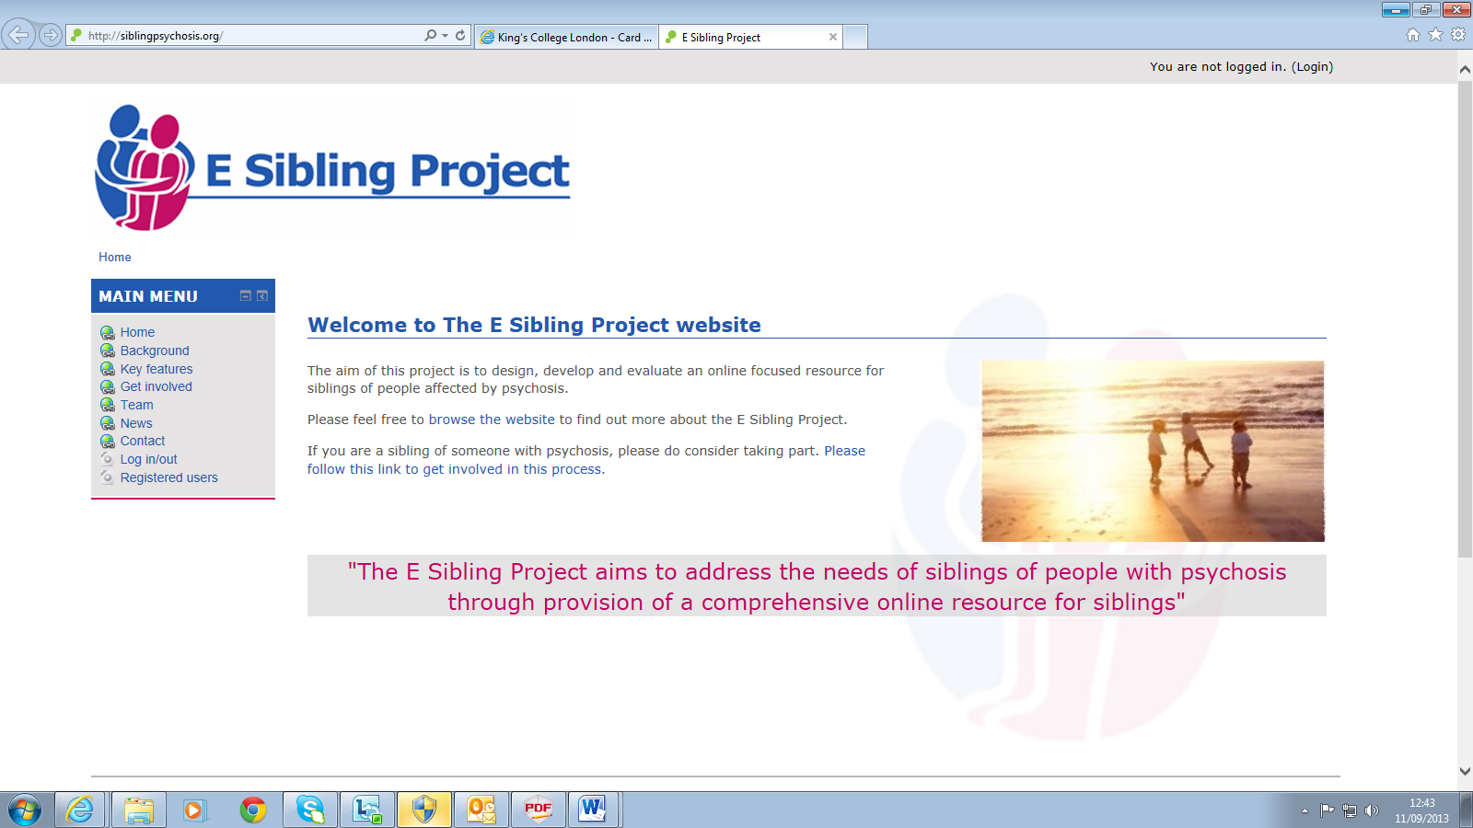

**Future work**

Support for siblings is a growing area of interest and development and the services and projects considered here will be key to the development and future direction of the support offered to siblings. The E Sibling Project online resource will remain exclusively accessible by research participants till the end of 2014. If the resource is proven to be effective and well-received by siblings, there are plans to open its provision to all.

In the meantime, considerations and innovations in collaborative working and service provisions are called for from all clinicians, health and social care workers when working with families and carers. *“What can we do?”* Think siblings! Signpost siblings to the online resources, campaigns and groups highlighted here.

**For further information please contact:**

**Jacqueline Sin**

**Email: Jacqueline.sin@kcl.ac.uk**

**References:**

Buist KL, Dekovic M, Prinzie P. (2013) Sibling relationship quality and psychopathology of children and adolescents: A meta analysis. *Clinical Psychology Review*; 33: 97-106.

Friedrich R.M., Lively S. & Ruberstein L.M. (2008) Siblings’ coping strategies and mental health services: A national study of siblings of persons with schizophrenia. *Psychiatric Services*, 59(3): 261-267.

Milevsky A. (2011) *Sibling Relationships in Childhood & Adolescence: Predictors & Outcomes.* New York: Columbia University Press.

Sin J., Moone N., Harris P., Scully E. & Wellman N. (2012) Understanding the experiences and service needs of siblings of individuals with first episode psychosis: A phenomenological study*. Early Intervention in Psychiatry*, 6: 53-59.

Sin J, Jordan C, Barley E, Henderson C, Norman I. (2013) *Psychoeducation for siblings of individuals with severe mental illness (Protocol). Cochrane Database of Systematic Reviews.* Issue 6. Art. No.: CD010540. DOI: 10.1002/14651858.CD010540. <http://onlinelibrary.wiley.com/doi/10.1002/14651858.CD010540/abstract>

Smith J., Fadden G. and O’Shea M. (2009) Interventions with siblings. In: Lobban F. and Barrowclough C. (Eds.) *A Casebook of Family Interventions for Psychosis*. Chichester: Wiley and Sons

Smith J., Fadden G. and Taylor L. (2010) The Needs of siblings in First Episode Psychosis. In: French P., Reed M., Smith J., Rayne M. and Shiers D. (Eds) *Early Intervention in Psychosis: Promoting Recovery.* Oxford: Blackwell Publishing Ltd.